KetteQ

Multi Echelon
Multi-Item
MuIti-Indenture
Optimization

Table of Contents

Multi Echelon Multi-Item MuIti-Indenture Optimization 0
1. General presentation 3
Target / Constraints 3
Wait time calculation 4
Sample – wait time calculation involving Multi Indenture and Multi Echelon 5
2. Data preparation 6
Data preparation and processes 6
a) Post Data import 6
b) Import 6
Inputs 6
c) Segmentation 6
d) Demand (firm open/close sales orders) 7
e) Forecast (lead time forecast) 7
f) Forecast accuracy measure 8
g) Lead times 8
h) Inventory 9
i) SKU level parameters 9
j) Optimization parameters 9
k) Bill of Distribution 11
l) Supersessions 12
m) Bill of Materials 13
n) Eoq/lot sizes 13
Data refinement 13
a) Demand/forecast rollup 13
b) Wait time. 14
c) Identify components and kits (used as an input of the main algorithm) 15
d) Diverse 15
3. Multi-echelon main algorithm 15
Objective function (at sku level) 15
a) Golden formula (Normal distribution) 16
b) Poisson 16
Objective calculation 17
Overall algorithm 17
Main functions and objects 18
a) MarginalValue è marginal_gain, dependant_changes_list 18
b) Commit_logged_value è marginal_gain, dependant_changes_list 21
c) Target dictionary 21
4. Practical setup of MEIO 21
Input tables. 21
a) Io_group 21
b) io_item_site_group 21
c) io_optimization_group 22
d) io_target_group 22
e) io_opt_tgt_group 22
f) io_optimization_group_skugroup 23
g) io_target_group_skugroup 23
5. To be implemented 23

General presentation
MEIO aims at maximizing a kpi (in this case fill rate) vs investment.
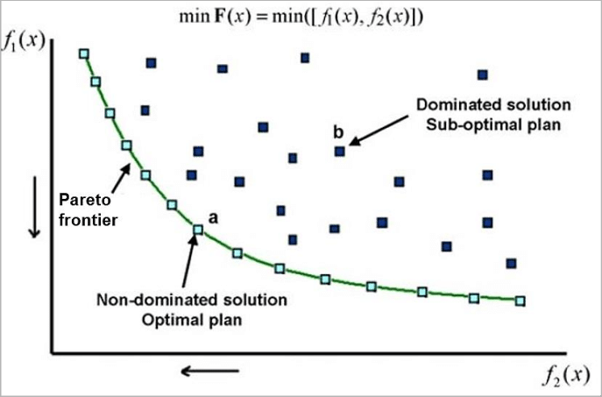
This version of MEIO understands constraints related to
- Multi-Item, some items are better investments than other and will for lower investment yield a higher fill rate
- Multi-echelon: the stocking policy of the various echelons matters. Essentially, if a part is not available at the next echelon, the time to purchase it should be accounted for.
- Multi-indenture: understands the constraint related to the BOM of kits
MEIO follows a heuristic algorithm sometimes named “bang for bucks”. In essence, it tests the added value (marginal value) created by adding one more item to the stock of each possible sku. Once determined the best one, the change is committed, and another test is performed.
The marginal value is determined as
- For each sku impacted by a change, the FR change is evaluated, it is weighted by the number of hits to obtain the gain
- This gain is then divided by the investment to achieve this gain.

Target / Constraints
MinFR can be defined per groups. Also, a max investment can be defined to understand the FR that can be obtained from a specific investment.

Wait time calculation
The wait time is related to the source of supply. In the case of parts, it can be either related to the above location buffer (the fill rate it offers to the next location)
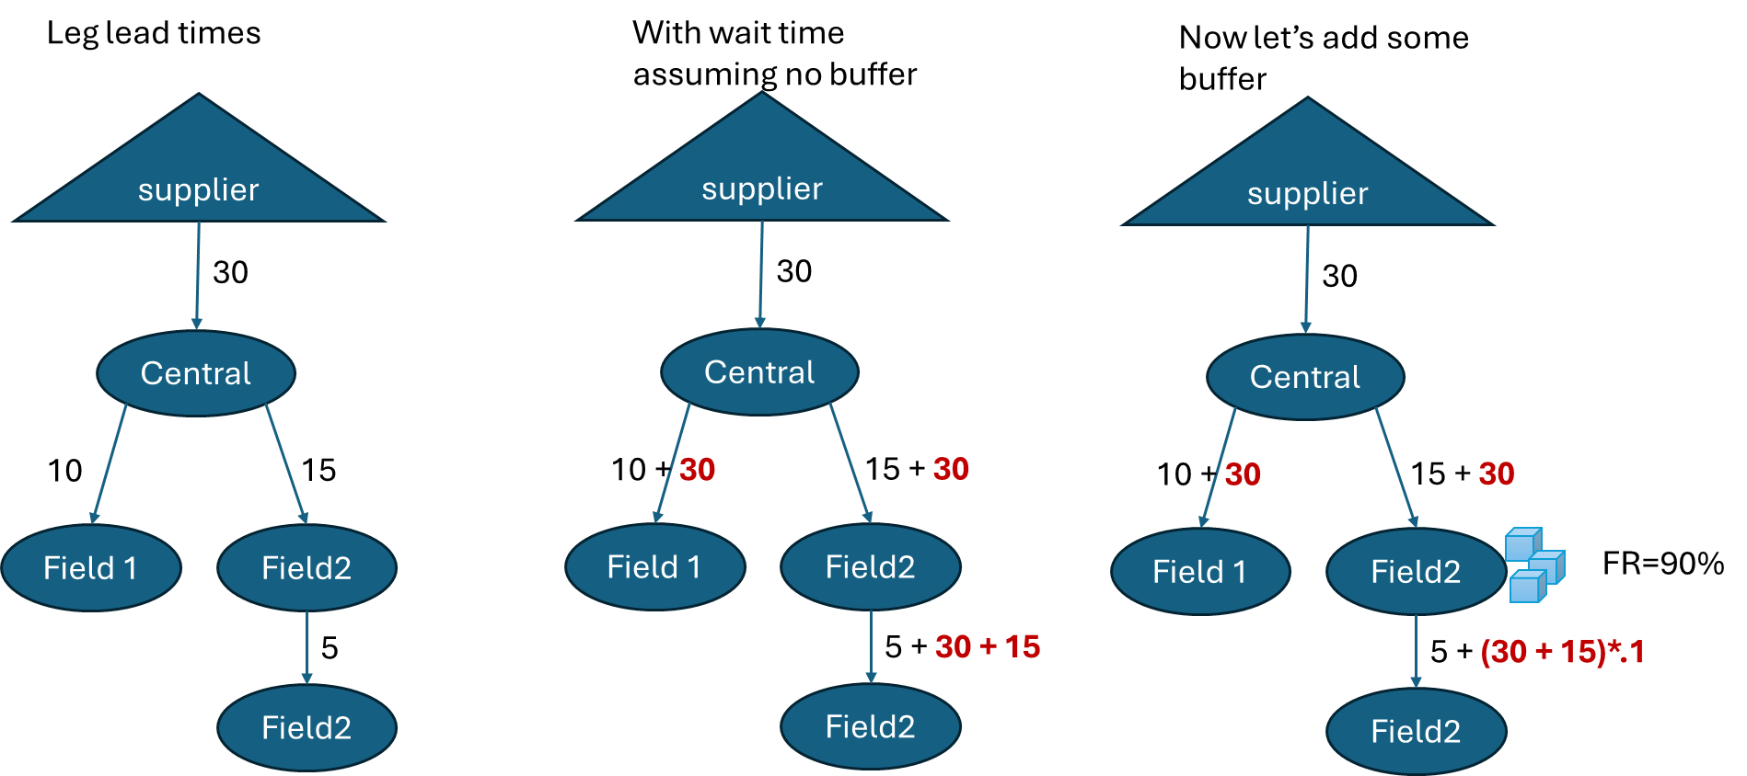

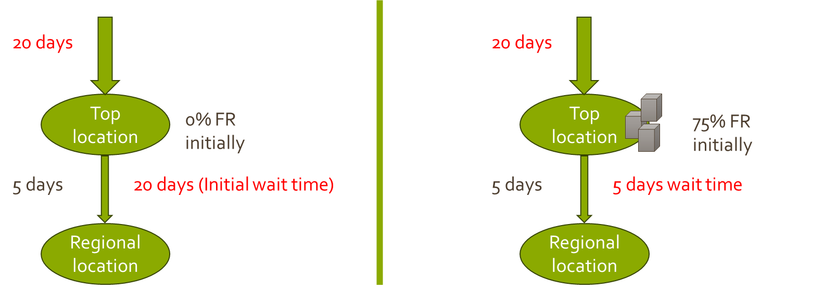

In the case of kits, it will depend on the availability of the components.
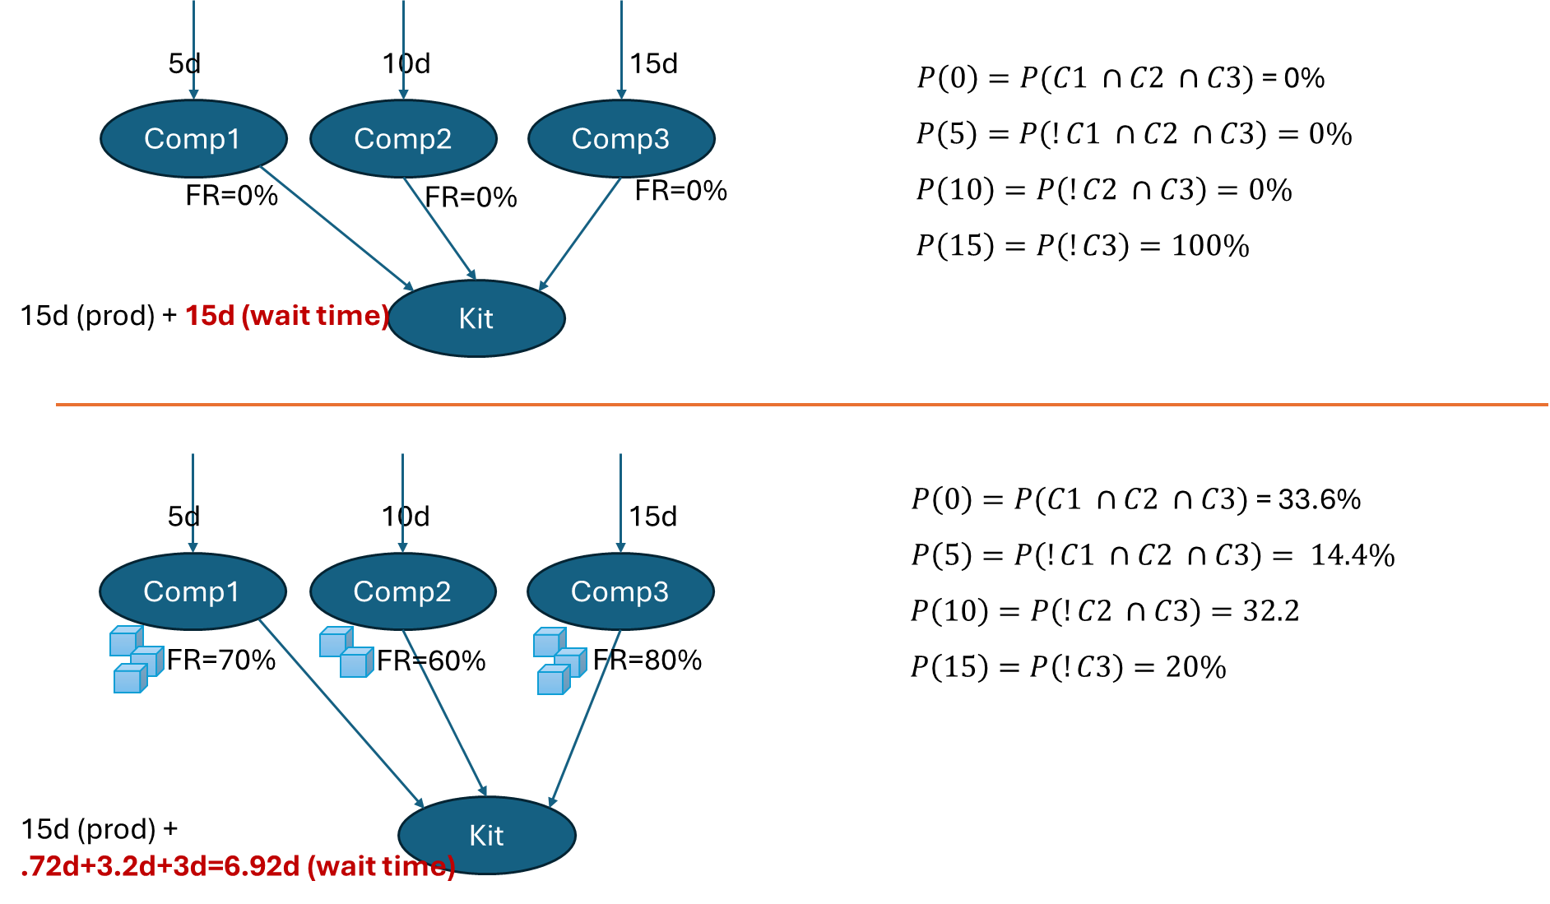

Sample – Initial wait time calculation involving Multi Indenture and Multi Echelon
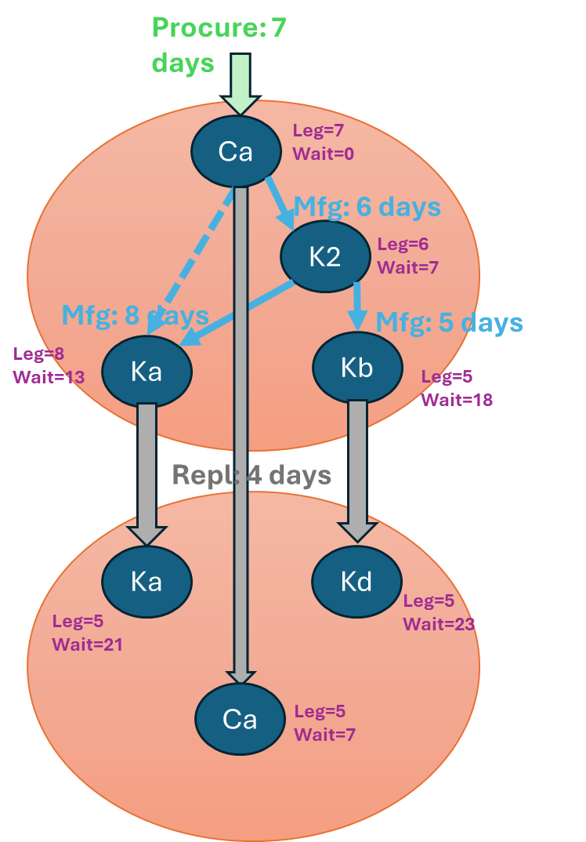

Note that MEIO does not understand supply options. A part is either make, procure or repl as far as planning is concerned. Sufficient info must be provided for the algorithm to select a unique lead time and supply option.
SELECT item_id , site_id
, max(supplier_id) supplier_id , max(rt.xuid) type_xuid , max(bom_alternate) bom_alternate
, max(lead_time) + max(pick_pack_time) + max(transit_time) + max(inspection_time)+ max(safety_lead_time)lead_time
FROM plan.route rou
JOIN plan.route_type rt ON rou.type_id =rt.id
GROUP BY item_id , site_id

Data preparation

Data preparation and processes
Several inputs required by MEIO are common to other processes such as forecasting and solve (supply plan)
Therefore, some data preparation should be positioned out of MEIO to benefit other processes.

Post Data import
- Recompute all chains (item_chain is only providing links in the chain, not the full chain with the topmost part that should hold full demand and stocks for the chain)
- Recompute boms to ensure that the bom is made of topmost parts only (for instance if K is made of B and C but C is replaced by D then K is made of B and D)
- Recompute rollups of demand and forecast (no recomputation of forecast at this stage but at least have the full forecast on the topmost part). This is required by MEIO as well as solve.

Import

- Python: ftp to postgres old/gen
- Run import scripts to create staging in postgres with a dblink to neon NG import
  - Run post import
- Move so to CH (Talend?)
- Run engines (sql and core)
- Move back to postgres and back to FTP

Inputs

Segmentation
Segmentation is the idea of associating a sku to various groups. These groups will then be associated to targets/constraints and various configurations.
The agreed format for segmentation is based on the inv_group_detail table. This table is assumed to be populated prior to the MEIO run.
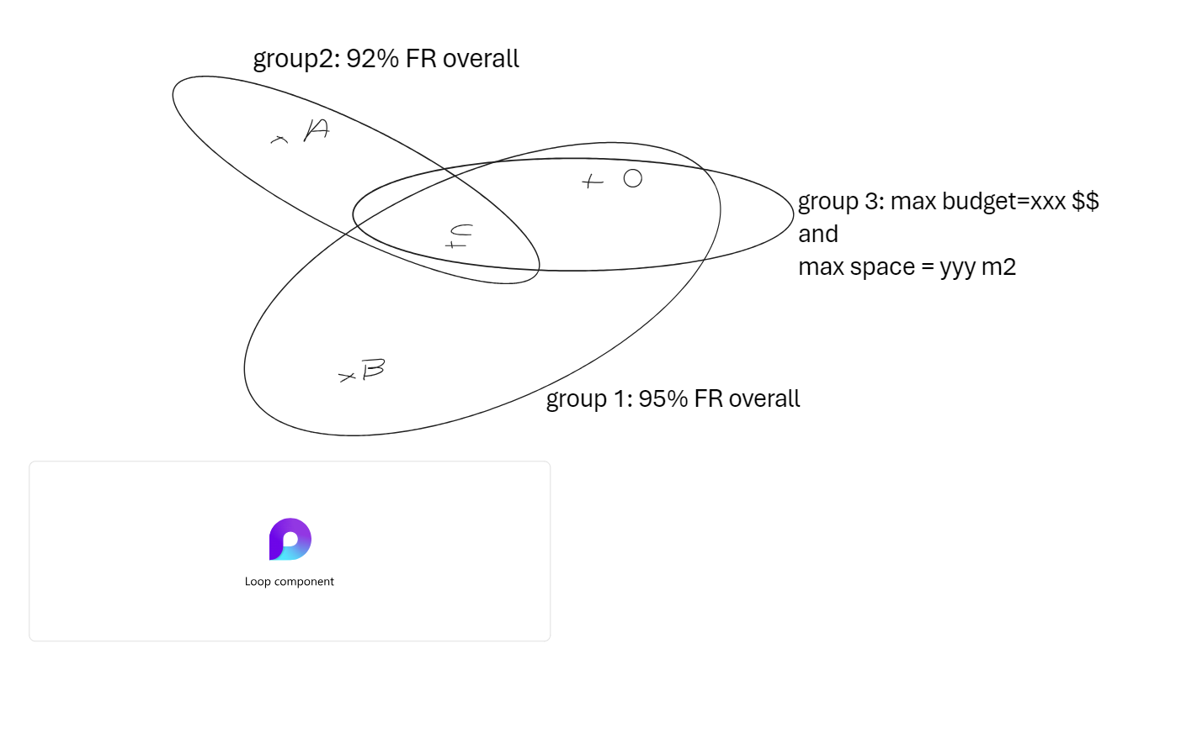
Item | Site | group
A | Site1 | Group2
C | Site1 | Group2
O | Site1 | Group3
O | Site1 | Group1
B | Site1 | Group1

sql_scope
Defines the scope for MEIO to run.

Tables

Inv_group

This table defines optimization groups. Optimization groups aim at describing targets for a given group of skus. For instance, EMEA may be targeting an overall target of 95% fill rate. MEIO on that basis would determine the best mix of items to reach the target whilst minimizing the costs.

id | xuid | name | description
1 | EMEA | EMEA | Europe
2 | APAC | APAC | Asia
3 | US | US | United states
4 | WORLD | WORLD | All

CREATE TABLE plan.inv_group (
id int8 GENERATED ALWAYS AS IDENTITY( INCREMENT BY 1 MINVALUE 1 MAXVALUE 9223372036854775807 START 1 CACHE 1 NO CYCLE) NOT NULL,
xuid text NOT NULL,
"name" text NOT NULL,
description text NULL,
CONSTRAINT inv_group_id_pk PRIMARY KEY (id),
CONSTRAINT inv_group_name_uidx UNIQUE (name),
CONSTRAINT inv_group_xuid_uidx UNIQUE (xuid)
);

-- Table Triggers

CREATE TRIGGER delta_log AFTER
INSERT
OR
DELETE
OR
UPDATE
ON
plan.inv_group FOR EACH ROW EXECUTE FUNCTION delta.capture();

inv_group_detail

-- DROP TABLE plan.inv_group_detail;

CREATE TABLE plan.inv_group_detail (
id int8 GENERATED ALWAYS AS IDENTITY( INCREMENT BY 1 MINVALUE 1 MAXVALUE 9223372036854775807 START 1 CACHE 1 NO CYCLE) NOT NULL,
item_id int8,
site_id int8,
child_group_id int8,
CONSTRAINT inv_group_detail_pk PRIMARY KEY (id),
CONSTRAINT inv_group_detail_uidx UNIQUE (id),
CONSTRAINT inv_group_detail_item_id_fk FOREIGN KEY (item_id) REFERENCES plan.item(id) ON DELETE CASCADE,
CONSTRAINT inv_group_detail_site_id_fk FOREIGN KEY (site_id) REFERENCES plan.site(id) ON DELETE CASCADE,
CONSTRAINT inv_group_detail_group_id_fk FOREIGN KEY (child_group_id) REFERENCES plan.inv_group_detail(id) ON DELETE CASCADE
);

-- Table Triggers

CREATE TRIGGER delta_log AFTER
INSERT
OR
DELETE
OR
UPDATE
ON
plan.inv_group FOR EACH ROW EXECUTE FUNCTION delta.capture();

inv_group_bounds

id | group_id | bound_type | min_value | max_value | currency_id |  |  | uom_id
1 | 1 | COST |  |  |  | 25000000 | 2
2 | 2 | FILL_RATE | 0.92
3 | 3 | FILL_RATE | 0.98
4 | 4 | FILL_RATE | 0.95
5 | 2 | SPACE |  |  |  | 485000 |  | 3
 | 1 | FILL_RATE | 0.9999

inv_items

inv_items holds all information for computing the supply order size (order_cost, holding_rate…)
The sql verifies the belonging of the sku to both the optimization group’s segments and the target group’s segments.
Additionally, the table holds the sku service_level if provided at this level. Any value in this table will override the ones set in the inv_group_bounds.

item_id | SKU
site_id
demand_policy_id
demand_history_interval_count
demand_future_interval_count
demand_default_forecast_error
demand_cov_max
auto_poisson_demand_stddev_threshold
auto_poisson_demand_mean_threshold
leadtime_policy_id
leadtime_mean | Override to lead time
leadtime_stddev | Override to lead time standard deviation
leadtime_to_demand_calendar_factor
policy_id
service_level | Override to the fill rate
interval_count
order_qty | Used in the Wilson formula
order_cost | Used in the Wilson formula
order_cost_currency_id | Used in the Wilson formula
holding_rate | Used in the Wilson formula
auto_poisson_demand_cov_threshold

Demand (firm open/close sales orders)
The reason for considering demand history is to understand the volume of the demand vs the size of the individual sales orders. This essentially will define line size.
Sales orders are not injected into the Neon database. Instead an aggregation of them will be provided in the plan.demand_actual table.
Two measures are expected in this table: ‘hits’ and ‘direct_demand’

The following SQL bases itself on the above data to compute
- Average custom order size
- Standard deviation
- Hits count
- Average demand since first demand
- First demand date
- Sum of demand since first demand
sql_history_stddev:
demand_actual
- item_id
- site_id
- qty
- measure_id
- date (month)
measure (for hits and actualdemand)
- id
- name (hits, actualdemand)

Forecast (lead time forecast)
The forecast is driving the stocks and is a major requirement for MEIO.
Two main measures are expected from the table dp_plan.dp_forecast : direct and indirect and their associated adjustments.
For the JCI project, direct demand is in the calc_qty column, this is configurable as per the sql below.
The following SQL describes the way MEIO expects to consume forecast (top most parts, direct and indirect demands aggregated)
SELECT dhm.item_id , dhm.site_id , df.date , df.""" + directDemandColumn + """ quantity
FROM dp_plan.dp_forecast df
JOIN dp_plan.dp_header_map dhm ON dhm.dp_item_id =df.dp_item_id AND dhm.dp_site_id =df.dp_site_id

sql_forecast_total
Forecast is extracted from:
- Dp_plan.dp_forecast
  - Dp_item_id
  - Dp_site_id
  - Calc_qty
  - Date
- Dp_plan.dp_header_map
  - Dp_item_id
  - Item_id
  - Dp_site_id
  - Site_id

Forecast accuracy measure
Identified in the sql: sql_forecast_total
forecast_sku_measure: is an input coming from the postforecast process. The currently used accuracy measure is RMAPE.

Lead times
Lead times are defined at item or sku levels. They represent the full lead time to the next node. They are found in the table plan.route. Lead times required for a sku are: the leg lead time (lead time from the next node)
For a kit: the lead time represents the kitting time (time to put the already available parts into the kit). The wait time is initially assumed as the max of the component lead time.
For a part or anything that is not a kit, it represents the time to send it from the higher node assuming it is available.
- Supplier lead time if the part is procured.
- Replenishment lead time in case of a stock transfer
The details of calculations of the lead time for both cases are described in the sub-sections BOD and BOM of this data input section
In the plan.route table, 3 lead times will be maintained
- Kit manufacturing/ general processing at the source: pick pack
- Transit: transit
- Inspection: inspection time

Kit lead times
sql_repl_hier
Extract the lead time as lead_time+pick_pack_time
- Route
  - Item_id
  - Site_id
  - Source_site_id (item_site_id) is assumed to be the same here.
This goes into io_repl_hier
This is then the basis for extracting the location hierarchy.

sql_lead_time
Extract the lead time as lead_time+pick_pack_time+transit_lead_time+inspection_lead_time
- Route
  - Item_id
  - Site_id
  - Source_site_id (item_site_id) is assumed to be the same here.
- Route_type
  - Xuid (Make, buy, repl)
This goes into io_lead_time

Inventory
Inventory can be used to identify min sl at no cost. Using this option allows for a smoother transition from where the current stocks are to the target stocks. This also leads to a higher refreshment frequency as inventory are refreshed every day.
Table used: plan.on_hand
The required type here is rolled up onhand. This is to be created post import. This type should be used by Inventory and more importantly by supply planning.
Field | Data Type | Description
id | int4 | Unique identifier
item_id | int4 | Unique item id
site_id | int4 | Unique site id
type_id | int4 | Type of the on stock (rolled up on hand)
qty | float8 | Opening stock available beginning of the planning
unit_cost | numeric(18,4) | The cost of buying the item

sql_sku_attributes
- Plan.on_hand
  - Item_id
  - Site_id
  - qty

Optimization parameters

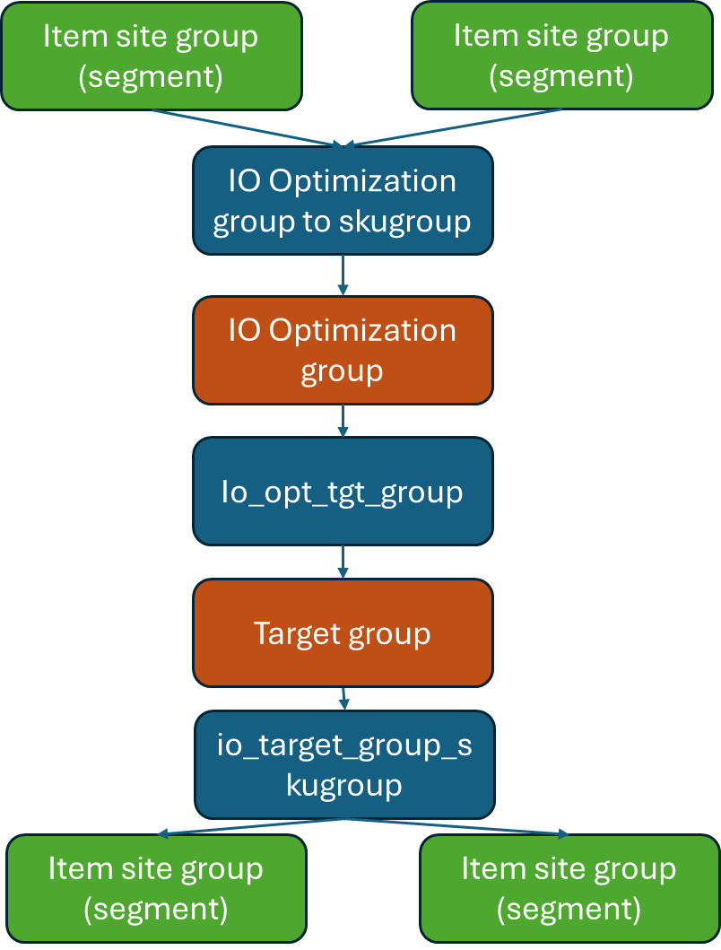

io_optimization_group
An optimization group associates
- A number of segments defining the scope considered
- A set of target groups, defining the targets and constraints considered in the scope defined above
Field | Data Type | Description
id | int4 | Unique identifier
name | String | Name of the optimization group
Fill_rate_type | Enum | Line/unit – definition for the related target groups

io_target_group
Field | Data Type | Description
id | int4 | Unique identifier
name | String | Name of the optimization group
Average_wait_time | Int4 | Not used for now but will be associated to EBO calculation
Fill_rate | Int4 | Fill_rate target (the choice unit vs line) is so far set at a higher level – optimization group
Max_budget | Int4 | To be used in conjunction of a very high fill rate. It essentially stops the algorithm when the budget is reached thus indicating the best FR reachable for a given budget
Sku_min_fill_rate | Int4 | Sku level fill rate: forces the fill rate of associated sku to at least this value
Sku_max_fill_rate | Int4 | Sku level constraint: Max fill rate constraint
Sku_min_safety_level | Int4 | Sku level constraint: min SL
Sku_max_safety_level | Int4 | Sku level constraints: max SL
Sku_min_safety_level_slice | Int4 | Sku level constraint: min SL expressed in demand slices (months)
Sku_max_safety_level_slice | Int4 | Sku level constraints: max SL expressed in demand slices (months)

Overall explanation of the configuration
- Each sku belongs to 1 and only 1 optimization group. An optimization group is limited in scope
- Each target group is associated with many sku AND the same sku can belong to many target groups (for instance, sku1 belongs to EMEA where 95% FR should be achieved, but also belongs to the critical item group that has to reach 98% FR)
- Each target group is associated with an optimization group
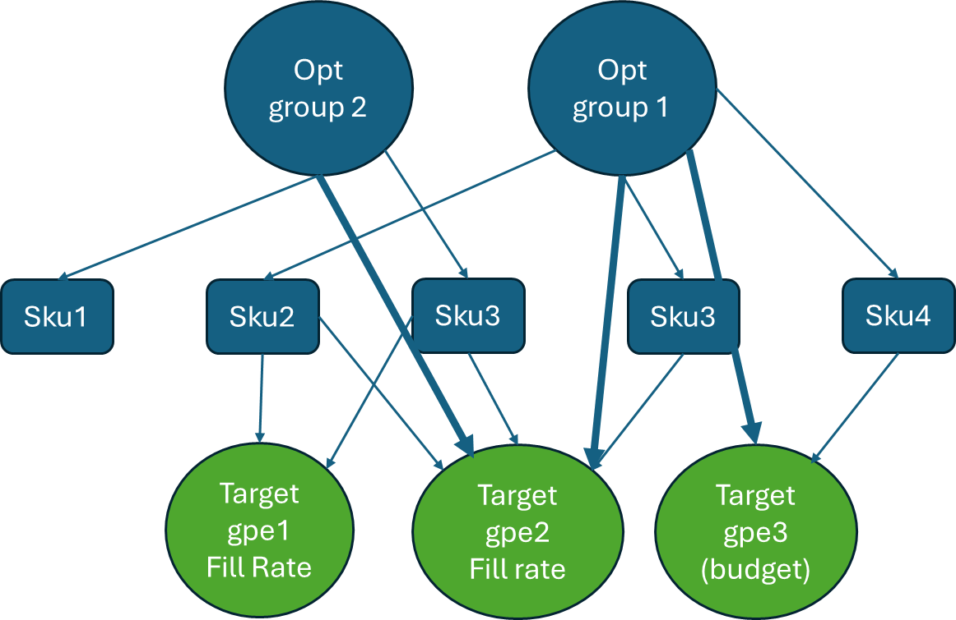

SKU level parameters
Stored currently in custom.io_target_group
- Min/max safety stock slices
- Min/max safety stock quantity
- Min/max fill rate (from parameters only)
- Min/max rop slices (from parameters only)

All tables have to be joined to give the results at sku level. The following excerpt identifies these tables and how they interact in accordance with the above graphs.
- from custom.io_item_site_group sd
- join custom.io_target_group_skugroup itgs on itgs.group_id =sd.group_id
- join custom.io_target_group itg on itg.id=itgs.target_group_id
- join custom.io_opt_tgt_group iotg on iotg.target_group_id =itg.id
- join custom.io_optimization_group iog on iog.id =iotg.optimization_group_id
- join custom.io_optimization_group_skugroup iogs on iogs.optimization_group_id =iog.id
- join custom.io_item_site_group sdopt on sdopt.group_id =iogs.group_id
- and sdopt.item_id=sd.item_id
- and sdopt.site_id=sd.site_id

Bill of Distribution
Plan.Route table in NG.

This represents the sourcing. Where is any part coming from? This also applies to kits that are purchase “as is”. It does not apply to kits that are built internally.
The expectation is that the full Bill of Distribution is represented for each part (and in priority 1)
Only the priority 1 routes will be considered (MEIO plans for the cheapest route, this may be reconsidered later to improve multi-sourcing consideration.
The Bill of distribution is used for 2 purposes.
- Rollup of the indirect network demand/forecast (this is supposed to be provided now as an input to MEIO). This calculation should be moved as a post forecast calculation.
- Rollup of aggregated wait time
Used columns in plan route (note that the blue rows are not used for the rollup of forecast or aggregated wait time)
Field | Data Type | Description
item_id | int4 | The item id which is going to be assembled
site_id | int4 | The site id to where the item is going to be assembled
supplier_id | int4 | The supplier id who is going to provide the material
type_id | int4 | The type of route id è this allows to understand whether this is a procurement/make/replenishment
source_item_id | int4 | The item id which is going to be consumed
source_site_id | int4 | The site id from where item is going to be consumed
min_qty | float8 | Used in another portion of the MEIO algorithm to determine resupply qty
mult_qty | float8 | Used in another portion of the MEIO algorithm to determine resupply qty
priority | int2 | The unique priority of the route – for MEIO only priority 1 are used
lead_time | int2 | The total time need by the route
pick_pack_time | int2 | The time needed to collect and packing the item
transit_time | int2 | The time needed to move the same material from one location to another
inspection_time | int2 | The time needed to check the quality of the item

All lead times summed up together as MEIO considers them as one.
Queries used:
- sql_loc_lt_hier

Supersessions
This is used to rollup demand to the top part as well as expressing all BOM with parts at the topmost revision. MEIO and subsequent processes require to work at topmost part level.
All processes on supersessions should be completed post import of the data. Processed chain involve the direct link of any part to its top most part, identifying whether demand and/or stocks should be rolledup.
Basic build of a chain

with recursive currentChain as (
SELECT 1 lvl, childitem.item_id top_item_id, childitem.site_id top_site_id, childitem.item_id, childitem.site_id, childitem.child_item_id, childitem.child_site_id
FROM plan.item_chain childitem
WHERE NOT EXISTS (SELECT 1 FROM plan.item_chain parentItem
WHERE childItem.item_id=parentItem.child_item_id AND childItem.site_id=parentItem.child_site_id
)
union
select cc.lvl+1 lvl, cc.top_item_id, cc.top_site_id, link.item_id, link.site_id, link.child_item_id, link.child_site_id
from currentChain cc
join plan.item_chain link on link.item_id=cc.child_item_id and link.site_id=cc.child_site_id
)
select * from currentChain
order by top_item_id, top_site_id, lvl

Table used: plan.item_chain
Field | Data Type | Description
Item_id | int4 | Replacing part
Site_id | int4 | Replacing site (assumed to be equal to the replaced site for now)
Child_item_id | int4 | Replaced part
Child_item_id | int4 | Replaced site
Policy_id | int4 | Should define the way demand/stocks are rolled up

Bill of Materials
Tables used: bill_of_material
sql_superseeded_kit
The bill of material is determined in the bill_of_material table. However, all elements are replaced by the top most part of their chain.
- bill_of_material
  - item_id
  - child_item_id
  - site_id
  - child_qty
- item_chain (component)
  - child_site_id
  - child_item_id
- item_chain (kit)
  - site_id
  - item_id

Eoq/lot sizes
SL depends on the size of the re-orders. For instance, a part with 0 SL, a reordering qty of 1000 and a demand of 10 per orders will be likely to have a very high FR (first order will be missed, but the next 999 will be filled out of the re-order of 1000) – this ignores the lead time of re-order-
This is in the plan.route table (see rows in blue)
Field | Data Type | Description
item_id | int4 | The item id which is going to be assembled
site_id | int4 | The site id to where the item is going to be assembled
supplier_id | int4 | The supplier id who is going to provide the material
type_id | int4 | The type of route id è this allows to understand whether this is a procurement/make/replenishment
source_item_id | int4 | The item id which is going to be consumed
source_site_id | int4 | The site id from where item is going to be consumed
min_qty | float8 | Used in another portion of the MEIO algorithm to determine resupply qty
mult_qty | float8 | Used in another portion of the MEIO algorithm to determine resupply qty
priority | int2 | The unique priority of the route – for MEIO only priority 1 are used
lead_time | int2 | The total time need by the route
pick_pack_time | int2 | The time needed to collect and packing the item
transit_time | int2 | The time needed to move the same material from one location to another
inspection_time | int2 | The time needed to check the quality of the item

Data refinement

The following table summarizes the final output of the algorithm: ketteq_custom.io_sku_output

Demand/forecast rollup

BOD rollup
This is done in the function: generateDependantReplForecastAndDemand
- sql_repl_hier: identifies the source (distribution) and the associated lead time
- sql_repl_hier_bottom_locs: identifies the lowest location in the BOD è io_repl_lvl
- rollup demand and forecast è io_repl_lvl
  - sql_insert_repl_dep: rollup forecast
  - sql_insert_repl_dep_dh: rollup demand history

BOM rollup
This is done in the function: generateDependantKitForecast
- execute generateKitForecastProcessingOrder to order each kit, subkit, component è io_kit_forecastprocessing_lvl
- rollup kit demand sql_insert_dep_kit_forecast_rollup level after level

Regroup all
- sql_total_forecast è io_total_forecast
- sql_fcst_over_lt: aggregate the forecast over lt (both for direct and indirect demand) è io_fcst

Wait time.

BOD (Bill of distribution wait time)
- The wait time for downstream locations is initially the sum of the lead times up to the top location.
- It then decreases as the upper location builds buffers (or not)



BOM ( Bill of materials)

- Multi-indenture is a similar but more complex concept to handle kits
- In a kit, the wait time is driven by the longest wait time for a component, so the algorithm will understand that this longest lead time is to be reduced to eventually reduce the number of orders.
- An important note is that the rollup is to be done respecting levels in the BOM. In the below example, Ca is foundation for K2 and Ka. Ca is a level 3 rollup as it comes after the highest below component (K2 is the highest level below Ca =2)
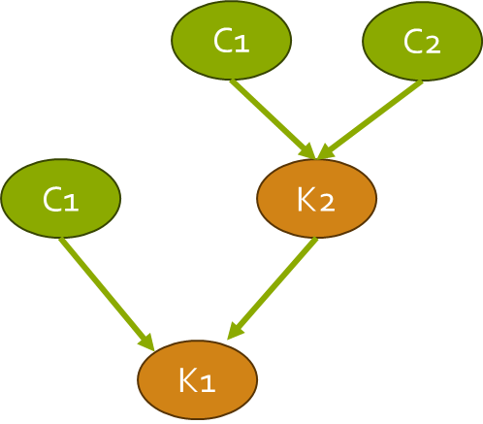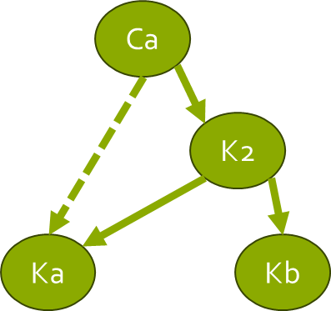
Execute generateDependantKitWaitTime
- generateKitLtProcessingOrder è io_kit_lt
  - Loop through levels and execute sql_insert_dep_kit_lt to compute full lead time

Identify components and kits (used as an input of the main algorithm)
- sql_component_to_kits è io_component_to_kits based on ketteq_custom.io_kit_processing_lt_lvl_master
- sql_kit_to_components è io_kit_to_components

Diverse
- Avgsize of sales orders + number of hits sql_average_size è io_avg_size
- Supplier lt: avg lt and standard deviation per supplier: sql_po_history_stddev è io_po_stddev
- Obtain all driving sku level parameters (sku_min/max_fill_rate, min/max safety level, min/max sl_slices, targets overall max budget, group fill rate. Based on scenario_engine_params/segments) è io_targets_per_sku

Multi-echelon main algorithm
Input: ketteq_custom.io_sku_attributes

Objective function (at sku level)

The objective function is determined based on the number of hits. Currently, the threshold is set to 25.
If under the threshold, the Poisson formula is used else the normal (golden formula) is used

Golden formula (Normal distribution)
The objective function describes what the target is and how it is computed. In the case of the current MEIO, the objective is Fill Rate.
While it is a temporary state, the objective function revolves around a normal or poisson distribution of the demand.
Considered inputs include:
- Lead time.
- Lead time variability.
- Demand over lead time.
- Order Size.
- Demand over lead time deviation from previous forecasting cycles as measured by the application (RMAPE). Standard is MAD.

- Normal distribution (golden formula)
Inputs:
- ROP= tested buffer (understand what can be gained from a defined ROP in term of FR)
- Reording size: eoq= The algorithm tests all values of eoq (between 1 and eoq) and will the average the results obtained in the described below algorithm
- Lead time= direct lead_time + calculated wait time for the sku
- Forecastlt= forecast over direct lead time + wait time
- Avgsize=this is used to evaluate the line fill rate
- lead_time_stdev=deviation of the lead time defines the need of a buffer
- dmd_stddev=this is used only if forecast accuracy could not be determined. It is made equal to demand forecast if the stddev cannot be computed.
- mape= while this is called map this refers to the forecast accuracy as configured in ketteq. In many cases, it is defined as MAD.
Output: Fill rate (line or unit). If we are targeting unit fill rate, unit is considered as equal to 1.
formula/algorithm: the fill rate is averaged over testing all order sizes values included within [1;eoq]
fill_rate=Cumulative_distribution_normal((ROP+tested_eoq-(forecastlt*avgsize)) / math.sqrt((((dailyRate) * (lead_time_stdev) )**2) + math.sqrt((1.25* mape* forecastlt * avgsize * math.sqrt(1/leadTimeMonth) )**2 *lead_time)))

Poisson
Inputs:
- ROP= tested buffer (understand what can be gained from a defined ROP in term of FR)
- Reording size: eoq= The algorithm tests all values of eoq (between 1 and eoq) and will the average the results obtained in the described below algorithm
- Forecastlt= forecast over direct lead time + wait time
- Avgsize=this is used to evaluate the line fill rate

Output: This return a Fill rate (either line or unit depending on the avgSize)
Formula:
total_fill_rate = poisson.cdf((rop+testedEoQ)/avgsize, forecastlt, 0 )

Objective calculation
The currently targeted objective is FR.
Two important things are to be noted. Deriving FR from buffer is based on total demand as the sku is not expected to have a specific fulfillment plan for direct or indirect and will have to face this full demand with the same FR.
However, when credit is taken at a system level for a sku FR, it is done based on the customer's FR as it eventually is the goal (indirect demand is a mean to achieve direct demand only)

Overall algorithm
- Read all data from the table ketteq_custom.io_sku_attributes. This table is at scenario/sku level.
- Initialize all skus computing the gain for each. This is stored in the maindataframe panda dataframe. The function MarginalValue is called to assess the gain for each SKU
  - MarginalValue: è gain, list of changes that represent this gain.
- Find in the dataframe the maximal gain [‘marginal_value’]
  - commit_logged_value
    - sku_completed, all_completed= commit_groups è assess whether targets are achieved (for the particular sku and for the group it is in). The idea, is to remove these from targets and if a group is considered as filled, then all gain for other skus have to be reassessed since they cannot gain from this group anymore
    - Loop through the changes incurred by the change in the particular SKU (list_of_dependant_changes)
      - For each dependant_change
        - Recompute the wait time for each dependant sku EffectiveLtFcst
        - Commit_groupsè commit the change for the sku inspected
    - marginal_value, dependant_changes_list = MarginalValue

Main functions and objects

MarginalValue è marginal_gain, dependant_changes_list
This function is run to understand the marginal_gain for a specific sku as well as the changes associated to this gain. Note that the change is not committed until, the mainloop identifies the gain as the highest and commits it to then recompute it.
This function is passed 2 rows:
- The current row: this is one of the skus for which availability may change due to the change of buffer in the main indexrow
- The mainIndexRow: this is where the change was tested (increase of buffer)
It also comes with 2 more parameters
- Override wait time: this is the wait time of the previously inspected row. This is the main driver for the gain at lower level. If the mainIndexRow’s buffer changes than the wait time will reduce as a ripple effect for all connected parts (kits, replenishing skus)
- mainInvestment: this is the cost of buffer increase. It is used to compute marginal values.
The wait time is what makes the link between the various echelons of the network.
Essentially the wait time of a sku is a function of
- The overall wait time it experiences (source repl lead time + wait time)
- The FR it offers on base of that (which determines how often we will have to wait 0 days vs how often we will have to wait for the overall wait time)
Below is an analysis of the evolution of lead time and waiting time for a regional location replenishing from a higher one.
- Initially the wait time of the lower location = the supply time for the highest one
- When a buffer is added to the higher location, the wait time is decreased for the lower location.
- From the perspective of the lower location, the lead time experienced is repl lt + buffer lt
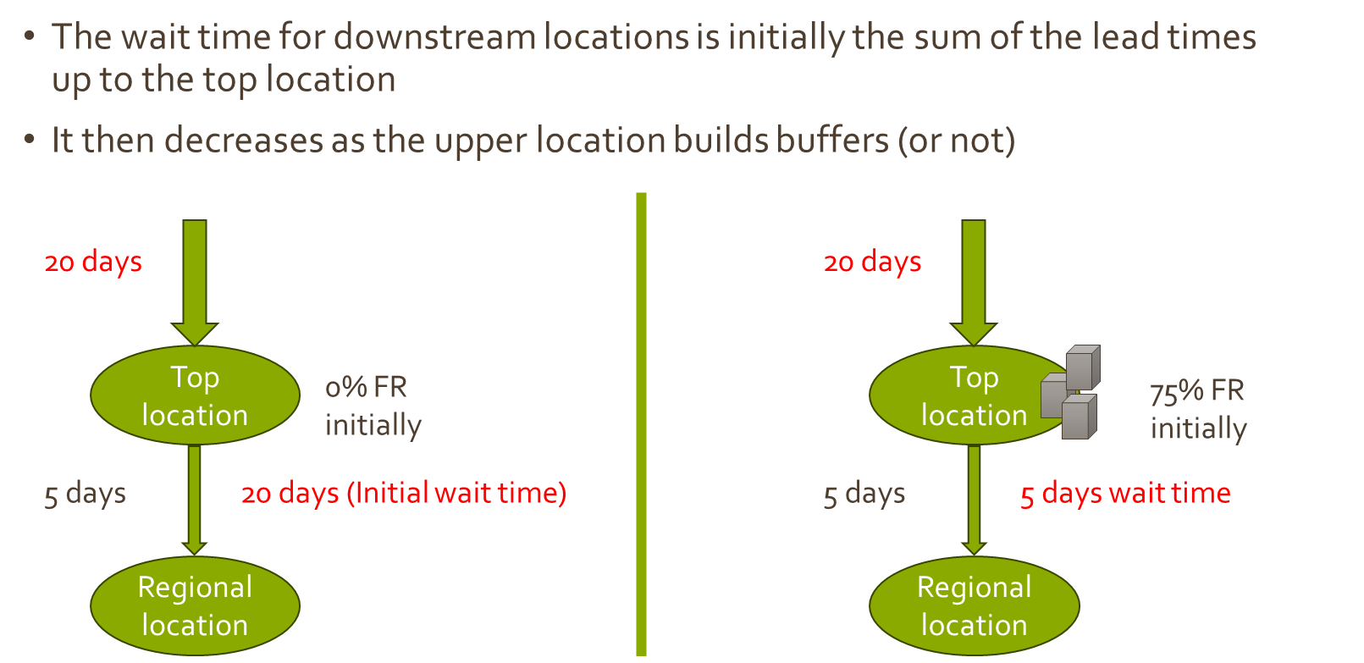
- The standard deviation is capped for both the lead time and the demand.
- The new demand over lead time is recomputed considering the override to the wait time.
- If the current row = mainDataRow then the first thing to do is to increase the buffer
  - If this is the first increment, we set the item on the ASL (ROP-> ltfcst)
  - If this is a subsequent increment, then the buffer should be increased. The next increase is currently determined by the next jump function that takes the precision parameter (as being the % of fill rate that we want to move on with as a minimum)
- If the current row is not the mainDatarow, it means that we are considering a dependant record, no change should be made to the buffer, the change to the marginal gain will come from the waitTime variation (parameter of the function)
- The new FR is then calculated using the new forecast over lead time together with the associated marginal value. The gain is also computed depending on the various groups it contributes to. This is done as part of the function group_completion_for_sku

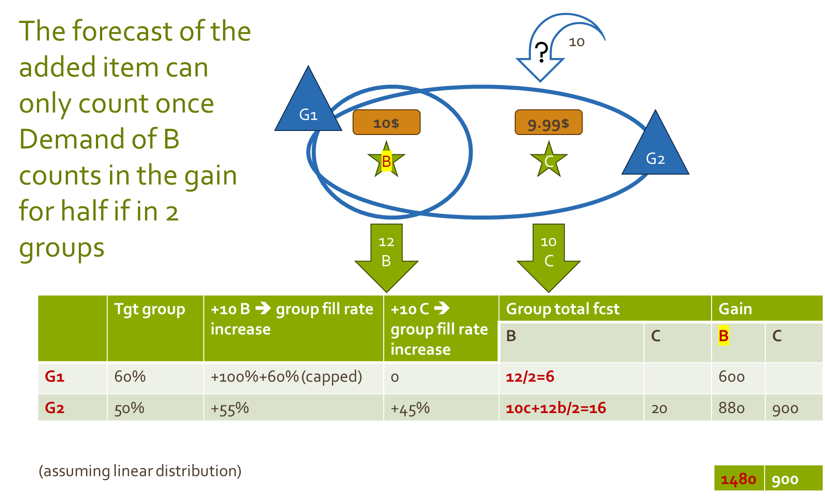

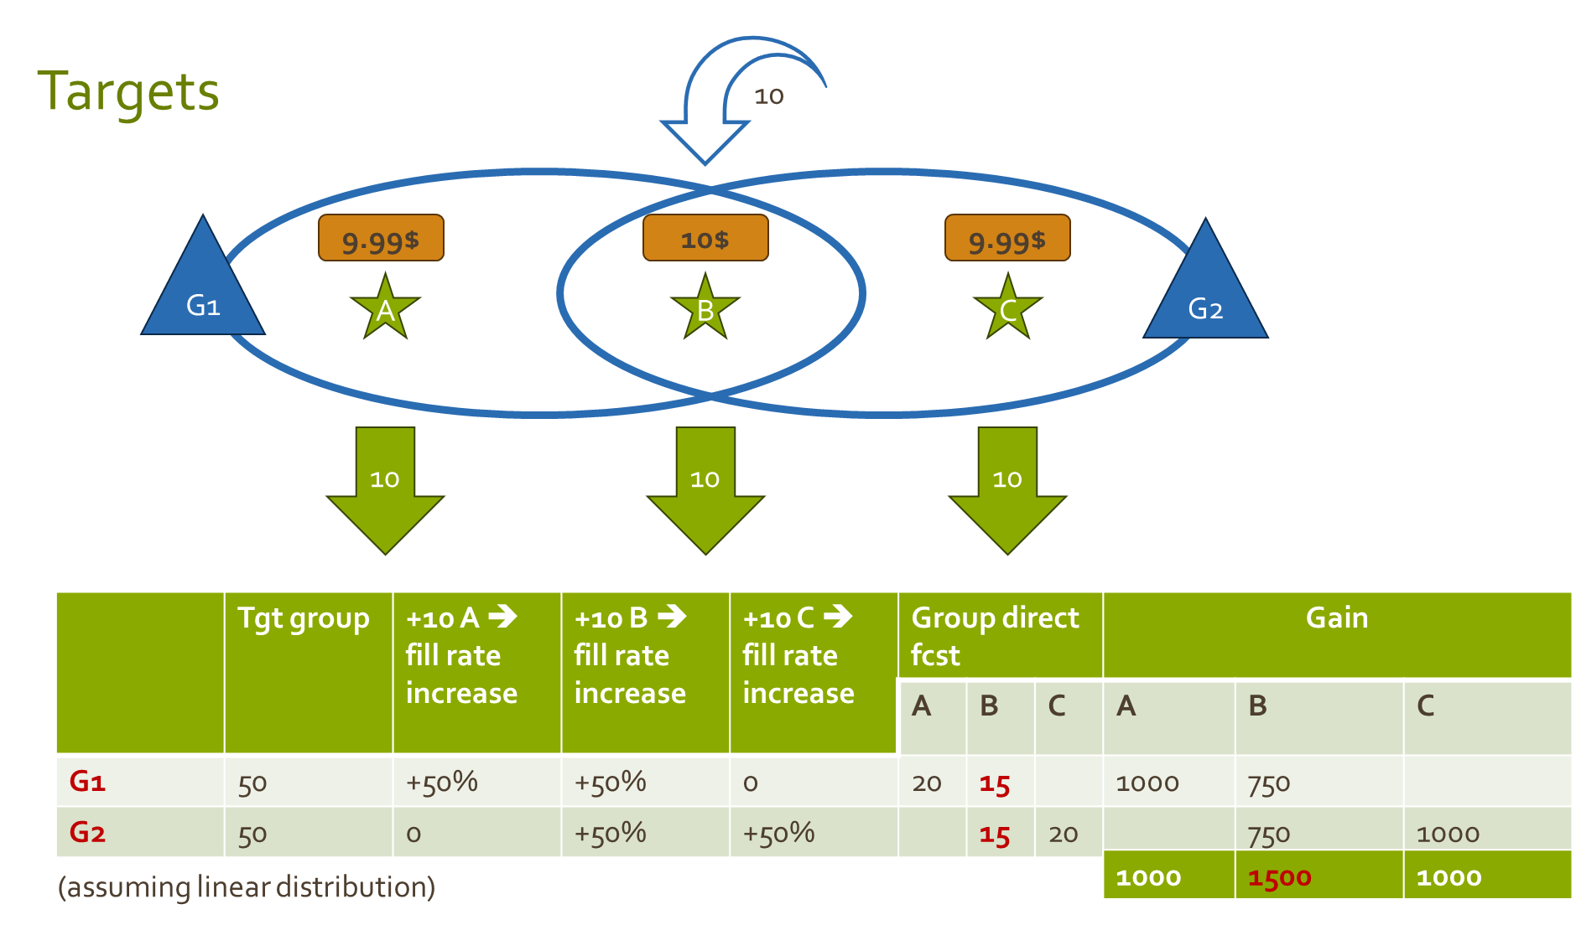

- Then all dependant skus are explored recursively
  - Replenishing skus:
    - The wait time for the currently modified sku is found and then passed as a parameter to the replenishing sku è call to MarginalValue
  - Associated kits that would benefit from the increase fill rate of a component è call to MarginalValue
- If the currentRow=mainRow (where the buffer was increased)
  - If the new FR is still under the max fill rate demanded then set for the sku
    - Marginal_value will later be the basis to pick this change and commit it.
    - New buffer (tested)
    - New sku fill rate
    - Dependant change list
  - If the FR is exceeding max sku FR, then the marginal_value is set to a large negative
- If the current row is not the main row, add the discovered changes to the list of changes that will then be part of the to do list when the sku is committed.

Commit_logged_value è marginal_gain, dependant_changes_list
This function commits the changes of the sku picked with the highest marginal value as well as the changes of all dependant sku.
It then calls MarginalValue to recompute the new added value of this sku after the change.

Target dictionary

Commit_groups (groups associated with the item, new FR, sku_direct_line_demand_rate…)
This function loops through all groups associated with the given sku.

Practical setup of MEIO

Input tables.

Io_group
Define the name of the part groups
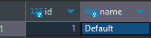

io_item_site_group
Associates the parts/site to the group. It will be used whenever we need to associate a specific feature to a scope.
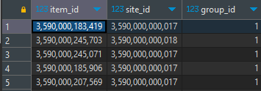

io_optimization_group
An optimization group is the medium to group constraints and targets that have to apply together. It also defines the scope overall where these constraints apply.
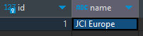

io_target_group
The target group defines targets and constraints. I will be linked to an io_group to define its scope.
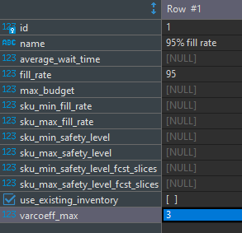

io_opt_tgt_group
This table associates an optimization group to the various target groups. It often will be a one to many relation.
For instance 1 optimization group will point to 2 target groups
- Target group1: 95% target overall
- Target group2: max budget for a specific site=2,000,000$
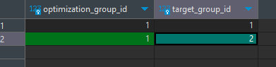

io_optimization_group_skugroup
In the same way as the above table, the optimization group will be associated with various groups of parts.
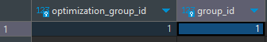

io_target_group_skugroup
Associates a target/constraint group object to its scope (group)
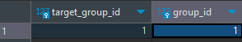

Output tables.
- Output for screens
  - Wait time and where it comes from
  - The indirect demand and where it comes from
  - The link between fr and units (based on distribution)
- Output of algorithm
  - Detail
    - Inv_item + some more columns

Screens

Configuration screens
- Create targets in the target group (FR, stock value…)

Top level screens
To be segmented
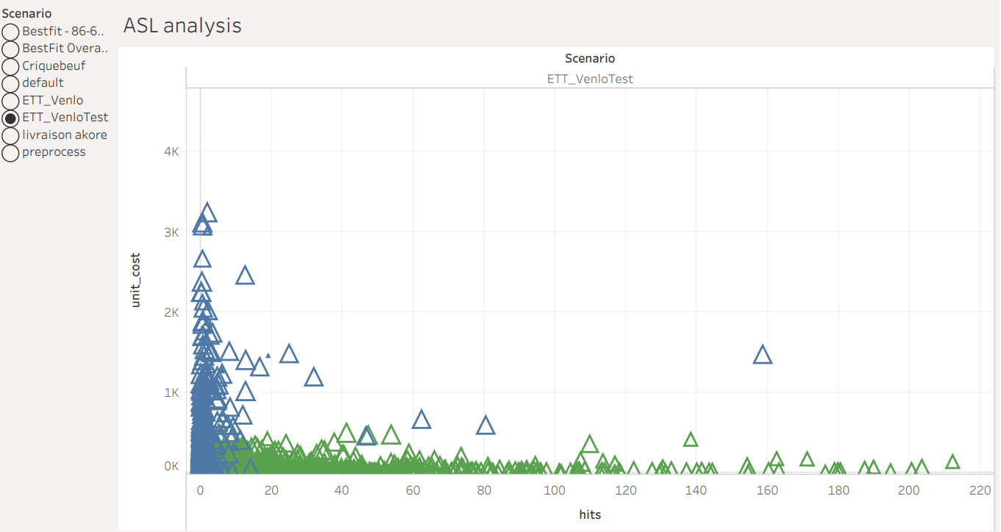
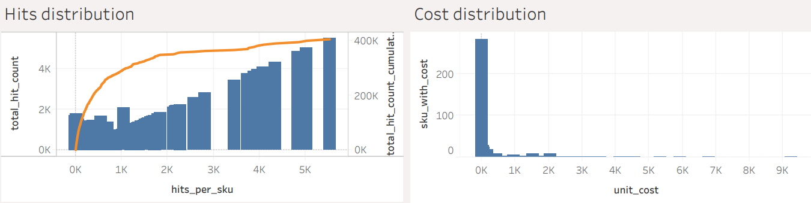
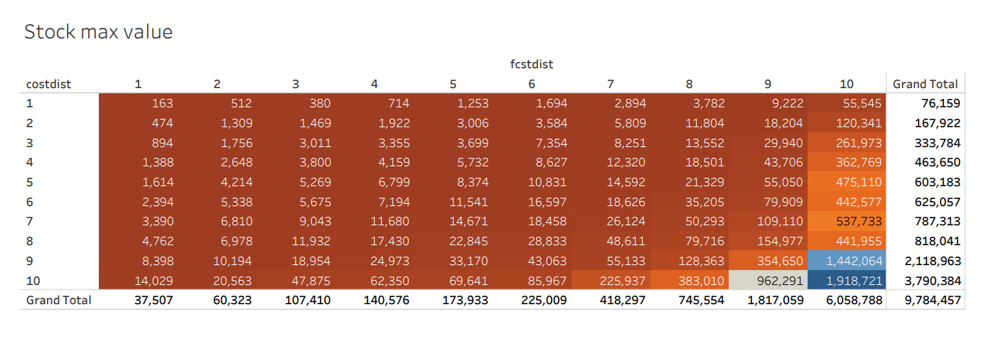
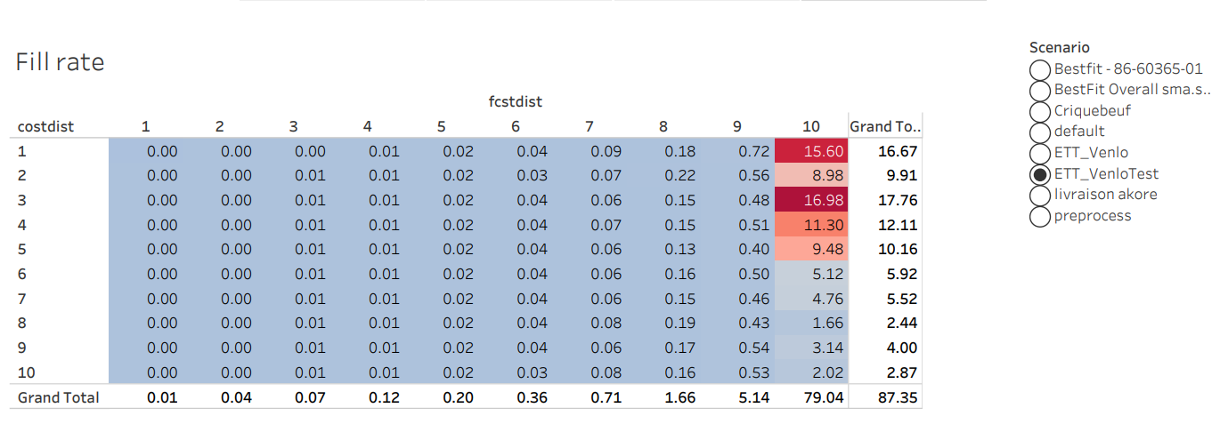

Sku detail screens
Representation of the links in term of lead time, wait time
- Kit
- Location hierarchy
- Lead time distribution
- Demand distribution

To be implemented
- As is, normal and Poisson distribution are assumed to compute a ROP. In the future, both demand and lead time should be forecasted, distribution of both forecast and lead time forecast error should be aggregated in a convolution of the distributions. This distribution shall be directly used to compute the stocks of the various SKUs. This will come close to the bootstrap method currently used by KetteQ.
- EBO should replace FR to compute the availability of the product
- Repair and return lead time + washrate… should be included in the computation to ensure the ability to handle a repair supply chain.
- Multi-threading and improved performance is to be reached. As of today, this is attempted through a Cython conversion of the code
- Handle more targets such as CO2, space, full costs (including expediting costs and others)
- Contract based optimization - divide the demand for the same sku and assign it to a particular contract (objectives)
- Assisting locations

